HOMEWORK

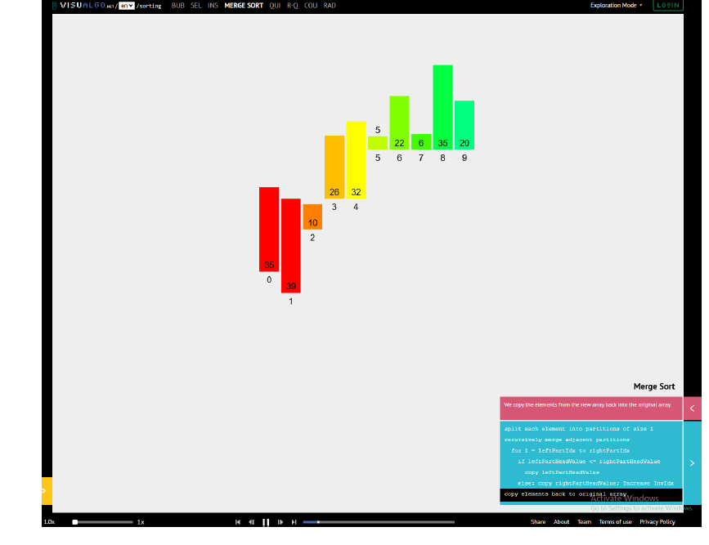

- Create a print for merge sort at each step. Explain what is happening!!

#include <iostream>
#include <vector>
using namespace std;

// Function to print the array
void printArray(vector<int>& arr) {
for (int num : arr) cout << num << " ";
cout << endl;
}

// Merge function to merge two halves and print each step
void merge(vector<int>& arr, int left, int mid, int right) {
vector<int> leftArr(arr.begin() + left, arr.begin() + mid + 1);
vector<int> rightArr(arr.begin() + mid + 1, arr.begin() + right + 1);

int i = 0, j = 0, k = left;
while (i < leftArr.size() && j < rightArr.size()) {
if (leftArr[i] <= rightArr[j]) arr[k++] = leftArr[i++];
else arr[k++] = rightArr[j++];
}

while (i < leftArr.size()) arr[k++] = leftArr[i++];
while (j < rightArr.size()) arr[k++] = rightArr[j++];

printArray(arr); // Print the array after merging
}

// Merge Sort function
void mergeSort(vector<int>& arr, int left, int right) {
if (left < right) {
int mid = left + (right - left) / 2;

mergeSort(arr, left, mid);
mergeSort(arr, mid + 1, right);
merge(arr, left, mid, right);
}
}

int main() {
vector<int> arr = {35, 39, 10, 26, 32, 5, 22, 6, 35, 20};
cout << "Initial array: ";
printArray(arr);

mergeSort(arr, 0, arr.size() - 1);

cout << "Sorted array: ";
printArray(arr);
return 0;
}

- Using Example a from quicksort implement a print of the array at each step.
Explain what is happening!!
Try even and odd number of elements in your test cases.

#include <iostream>
#include <vector>
using namespace std;

// Function to print the array at each step
void printArray(vector<int>& arr) {
for (int num : arr) cout << num << " ";
cout << endl;
}

// Partition function for QuickSort
int partition(vector<int>& arr, int low, int high) {
int pivot = arr[high]; // Choosing last element as pivot
int i = low - 1;

for (int j = low; j < high; j++) {
if (arr[j] < pivot) {
i++;
swap(arr[i], arr[j]);
}
}
swap(arr[i + 1], arr[high]);
printArray(arr); // Print the array after partitioning
return i + 1;
}

// QuickSort function
void quickSort(vector<int>& arr, int low, int high) {
if (low < high) {
int pi = partition(arr, low, high);

quickSort(arr, low, pi - 1);
quickSort(arr, pi + 1, high);
}
}

int main() {
vector<int> evenArr = {35, 39, 10, 26, 32, 5, 22, 6, 35, 20};
vector<int> oddArr = {40, 15, 30, 10, 5, 50, 25};

cout << "Initial even-sized array: ";
printArray(evenArr);
quickSort(evenArr, 0, evenArr.size() - 1);
cout << "Sorted even-sized array: ";
printArray(evenArr);

cout << "\nInitial odd-sized array: ";
printArray(oddArr);
quickSort(oddArr, 0, oddArr.size() - 1);
cout << "Sorted odd-sized array: ";
printArray(oddArr);

return 0;
}

